Data Exploration

Project Analysis Name: Data Exploration of Order and Shipping Country
Code: NMN0001
Originator of Data: Ahmed Samir
Platform of Origination: Kaggle
URL: https://www.kaggle.com/datasets/ahmedsamir11111/project-data-analysis-using-using-excel
Data Analyst: Nigel Masiyazi-Ngorima

Data Background
Data has no background history of where it came from. The idea is to explore and discover what stories the data tells then give full history of the data.

Tools Used
- Excel
- Power BI

Data Files Attached
- Data Cleaning and Processing.xlsx
- ShipmentData.pbix

Step 1: Data Cleaning
All Data cleaning was done on Excel and all formulas used are available in the ‘Data Cleaning and Processing.xlsx’ file. All referencing of methods will be mentioned on which Worksheet to find information.
- All Data was duplicated on to the working Excel file.
- Order table Created in ORDER DATA Worksheet.
- Summary Data of Orders Worksheet checks for Unique values, missing entries, consistency and the number of categories available in each Column set.
- Upon discovering in Step 1.3 that Product ID and Names are not uniquely matched, Product Data Worksheet was created to identify and analyze why there are discrepancies.
- Analyses provide that the error originates from Data entry as Product ID had at most 2 different names to it. The data entry error has two types of errors:
  - Name description entered wrong
  - System where the data comes from has missing Product IDs matching the Product Names.
- Any further work required on the data will ignore the Product Name and focus on Product ID, but error has been noted.
- Order table is complete.
- Shipping Cost Table created in Shipping Data Worksheet.
- Summary Data of Shipping Worksheet checks for Unique state entries and missing entries.
- Upon discovering in step 1.9 there is a duplicate state with different cost values.
- New table with updated data in Shipping Data is created with the new value that is averaged for duplicate state entry.
- Returns Data Worksheet checks for Unique responses on the column returned and to check if the order exists in the original data from ORDERS DATA Worksheet. Analysis shows that all data matched with no errors.
- Persons Table Worksheet from visual observation is clear from any errors.
The data is cleaned and ready for any analytical processes.

Step 2: Visual Exploration
All data visualization was completed on Power BI extracted from the cleaned excel file. All Visualization found on ‘ShipmentData.pbix’ Since the data has no background and is just raw data. Initial step is to visualize each category so to understand what the data gives.
Category Visualization:
- Sales
- Profit
- Shipment

  - Sales Visualization and Analysis
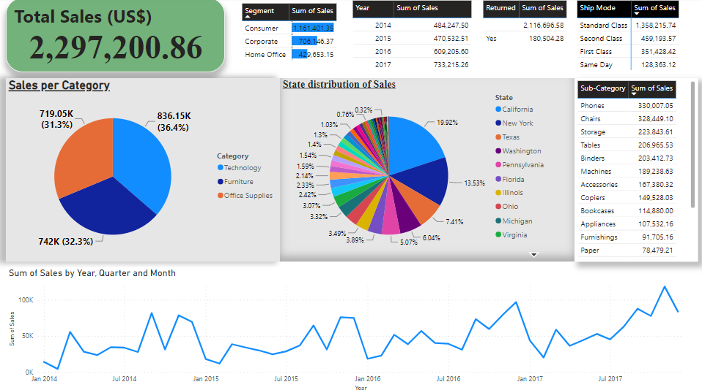
- Total sales made from 2014-2017 is US$2,297,200.86 with the following breakdown:
Year | Sales (US$)
2014 | 484,247.50
2015 | 470,532.51
2016 | 609,205.51
2017 | 733,215.26
- This shows a growth of Sales from 2014-2017.
- On the Sales Dashboard the Pie-Chart of Sales per Category shows that Technology contributes 36.4% of the total sales followed by Furniture at 32.3% and then Office supplies at 31.3%. The Yearly distribution is as follows:
Year | Technology | Furniture | Office Supplies
2014 | 7.63% | 6.84% | 6.61%
2015 | 7.09% | 7.42% | 5.97%
2016 | 9.85% | 8.66% | 8.01%
2017 | 11.83% | 9.38% | 10.71%

- Generally, Technology has the highest contribution in sales each year except in 2015 where Furniture had the highest contribution.
- On the Sales Dashboard the Pie-Chart of State distribution of Sales shows that California contributes the most to the total sales at 19.92% followed by New York at 13.53%, Texas at 7.41%, Washington at 6.04%, Pennsylvania at 5.07% with the rest of the states contributing less than 5% each.
- Further Visualization from product category and year show California leading in the most sales contribution compared to other states.
- On the Sales Dashboard the line-graph of sales from 2014-2017, show that sales are low beginning of each year but gradually grow over the course of the year.
- Segmentation of the clients the consumers are the highest contribution to sales followed by Corporates then Home Offices.
  - Profits Visualization and Analysis
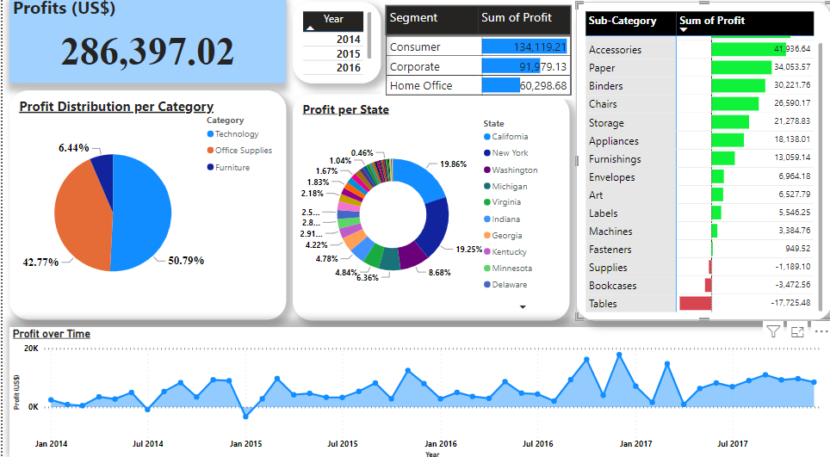
- From the Profit Dashboard, the total profit for the company in the 4 years is US$286,397.02:

- From the graph its clearly seen that the company profit is increasing every year.
- Technology has the highest profit contribution to the company at 50.79% followed by office supplies at 42.77% with the lowest at 6.44% which is furniture.
- From the visual graph of profit over time from the Profit dashboard, profit starts low at the beginning of the year and increases over the year period.
- Profit on the monthly bases is positive except for:
Month, Year | Profit Value (US$)
July, 2014 | -841.48
January, 2015 | -3,281.01

- As per the sub-category table, the following registered loses:
Sub Category | Profit Value (US$)
Supplies | -1,189.10
Bookcases | -3,472.56
Tables | -17,725.28
- Based on yearly losses it is as follows:
Year | Sub-categories
2014 | Tables, Bookcases
2015 | Tables, Bookcases, Supplies
2016 | Tables, Supplies
2017 | Tables, Machines, Bookcases, Supplies
- This shows that the tables do not make profit for the company in all the 4 years whilst Bookcases and supplies appear 3 times as losses. Machines shows a significant loss in 2017 only with US$-2,880.22.
- The cliental that provides the most profit for the company is Consumers.
- The states that provide the most profit is California at 19.86%, New York at 19.25%, Washington at 8.68%, Michigan at 8.68% and the rest of the states below 5% each.
Shipment Visualization and Analysis
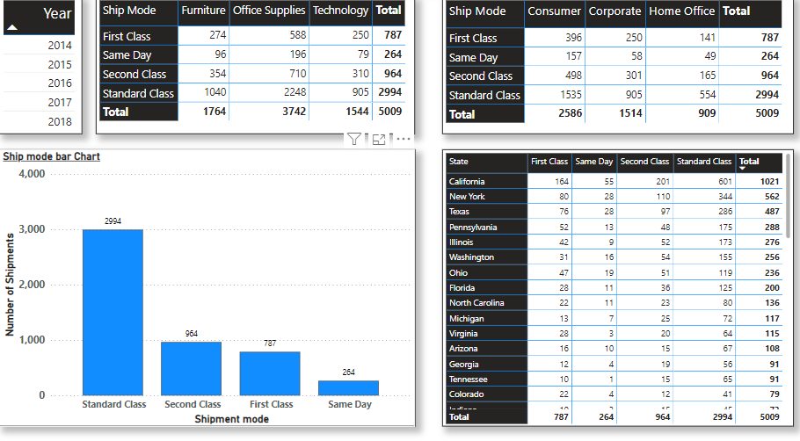
- From the Shipment dashboard, most used shipping method is Standard class.
- Most shipped product category are office supplies.
- Consumers have the most shipment.
- California has the most shipments.
Conclusion Visualization and Analysis
The Data shows a company that is in shipment of products categories that are covered in office supplies, technology and furniture. The business main course is to deliver across all the states in USA.
From the data there are different methods that their clients use for delivery. The company has cost to complete a delivery and profit they realize.
The questions now left from the data are:
- Which key aspects of the business need more attention to maintain high profits?
- Which areas of the business are affecting maximum profit to be realized?
- What does the future predict at the current trend given by the data?

Step 3: Data Analysis

